**Exercise 4b**

**Conduct task analysis for an app (e.g., online shopping) and**

**document user flows. Create corresponding wireframes using dia**

**Aim:**

The aim is to perform task analysis for an app, such as online shopping, document

user flows, and create corresponding wireframes using Dia.

**Procedure:**

1. **Install Dia:**

* Download and install Dia from [dia-installer.de](http://dia-installer.de/).
* Open the Dia application.

1. **Create New Diagram:**

* Go to File → New Diagram.
* Choose "Flowchart" as the diagram type.

1. **Add Shapes:**

* Use shape tools (rectangles, ellipses) for screens like Home Page, Product Categories, Product Listings, Cart, etc.

1. **Connect Shapes:**

* Use the line tool to connect shapes in the user flow (e.g., Home Page → Product Categories → Cart).

1. **Label Shapes:**

* Double-click each shape to label it (e.g., "Home Page," "Checkout").

1. **Save the Diagram:**

* Go to File → Save As and name the diagram (e.g., "Online Shopping App User Flows").

**Output:**

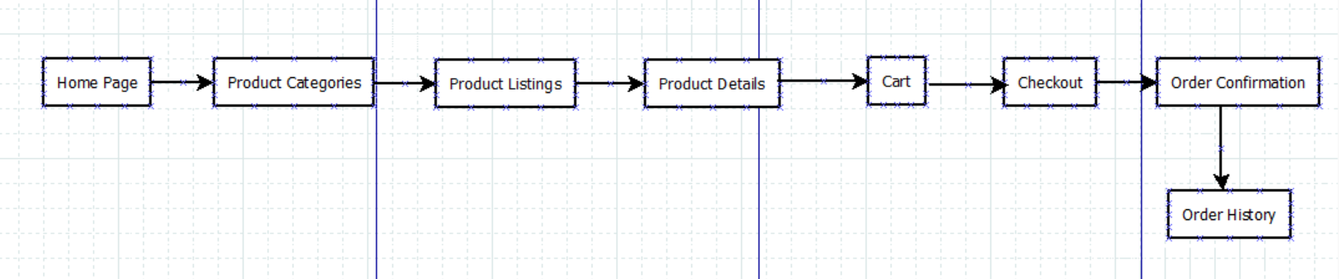

**Result:**

Hence, task analysis for an app has been executed successfully using Dia.